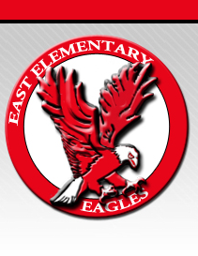 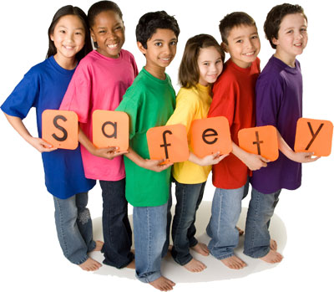

**School**

**Wide**

**Positive**

**Behavior**

**Support**



East Elementary

1229 E. McCarty

Jefferson City, MO 65101

**Respect**

**Responsibility**

**Safety**

**The Big Three**

The children and teachers at East Elementary are learning how to use the Big 3 to focus on learning. Please review the East School Matrix of Expectations with your child. Your support and reminders will help your child be an awesome student at East Elementary.

Thank you,

SW-PBS Team

SW-PB

S

## Dear Families,

*Over 340 Missouri schools participated in SW-PBS during the 2008-2009 school year.

*Other local school districts participating in SW-PBS include: Columbia, Mexico, New Bloomfield, Montgomery County, and Fulton.

*SW-PBS has been in use for over 10 years in the state of Missouri.

*East School is in phase two of a three-year phase.

For more information about SW-PBS you can visit:

[www.pbismissouri.org](http://www.pbismissouri.org) or www.pbis.org

Our goal is to help each child develop self-discipline. Together the home and school share the responsibility for developing good citizens. Parents, teachers, and students must work together to maintain a safe learning environment. The PBS (Positive Behavior Support) program is based upon recognizing positive contributions of students. SW-PBS means that teachers, administrators, counselors, and support staff are going to take responsibility to TEACH positive behavior expectations to students.

# What does School-Wide PBS mean?

### SW-PBS Facts